Module 5

Assignment 5.2
Course: CSD420-340A Advanced Java for Programmers
Prepared By: Mirach Erkol
Date of Report: 4/19/2026

https://github.com/Mikey5007/csd-420.git

5.2 Assignment: Running in PowerShell
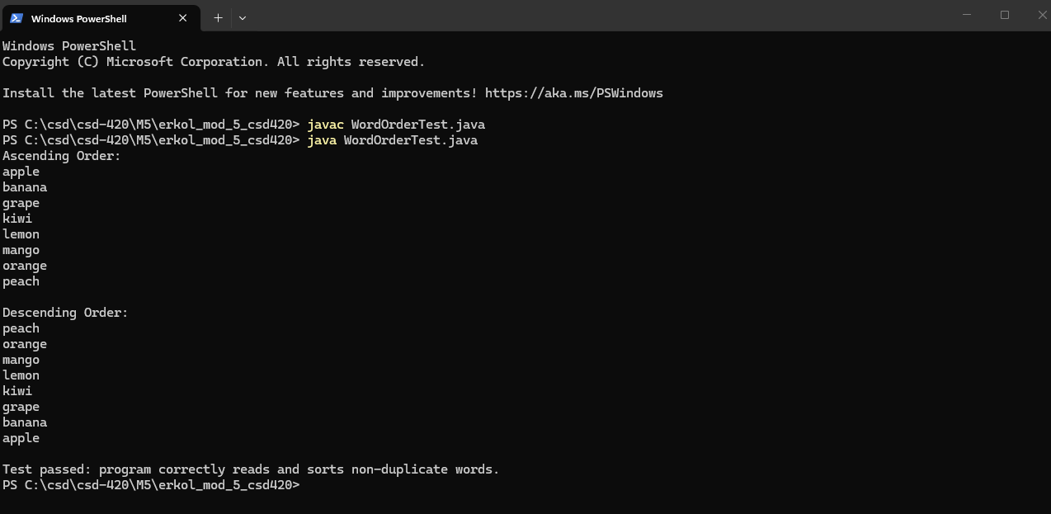

5.2 Assignment: Running in NetBeans
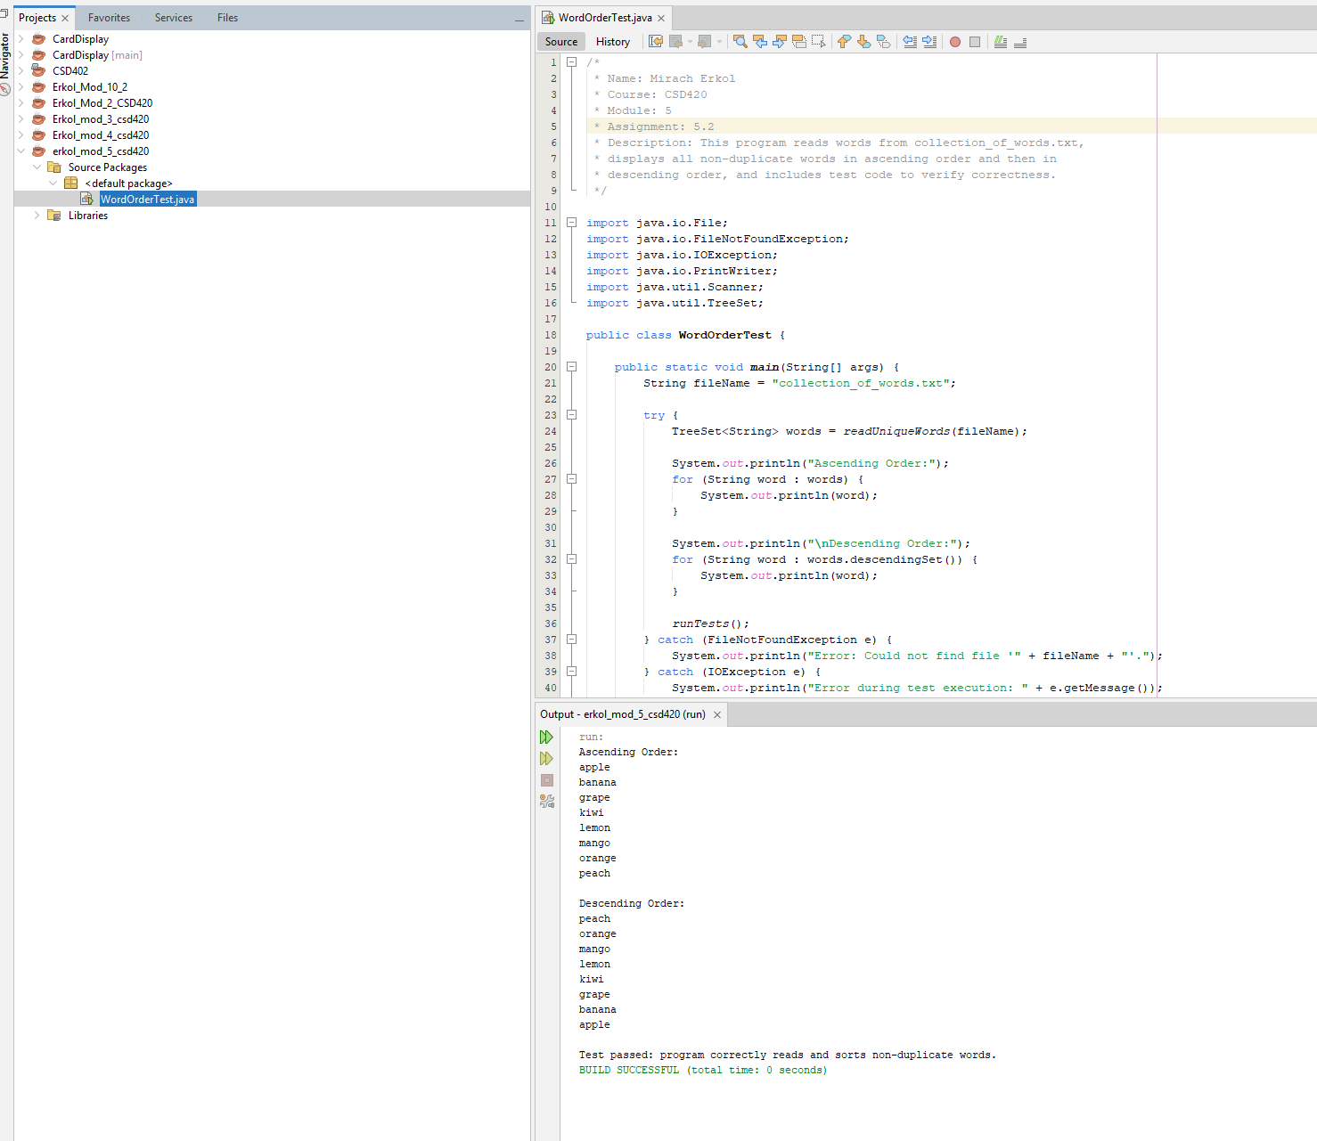

References:

https://github.com/Mikey5007/csd-420.git

